# Installed Jenkins and Create Project

A simple project to integrate GitHub repository and to print “Integration in Successfully Done”

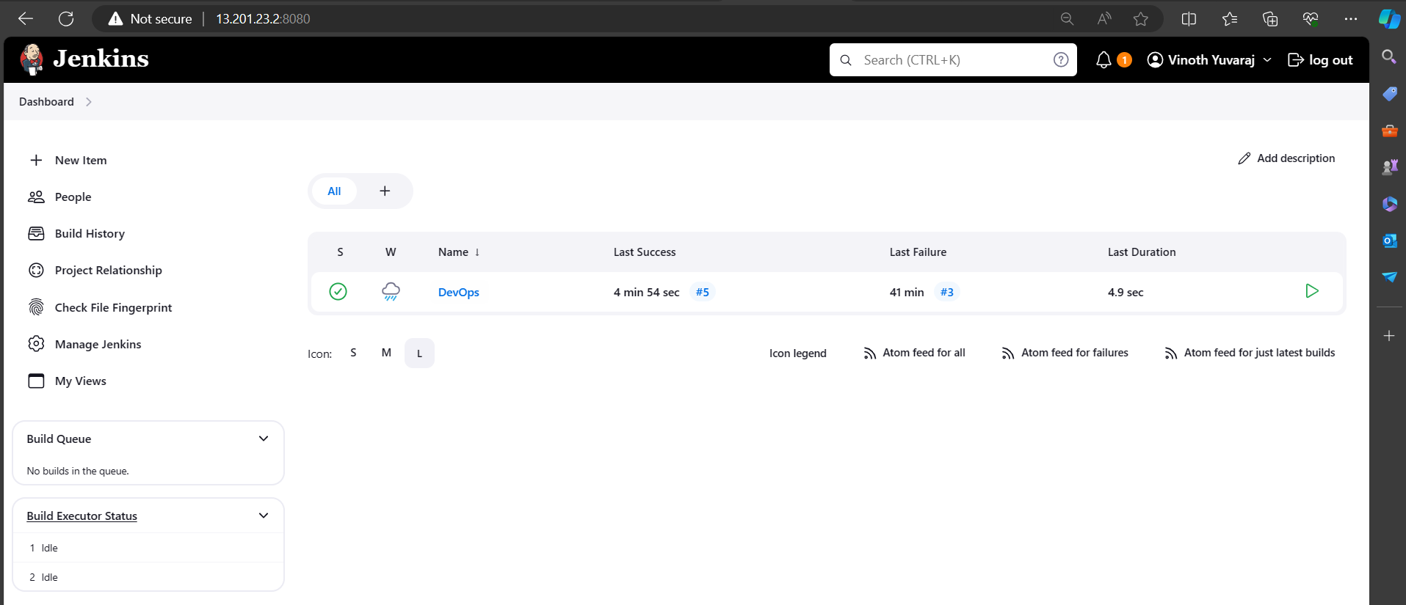

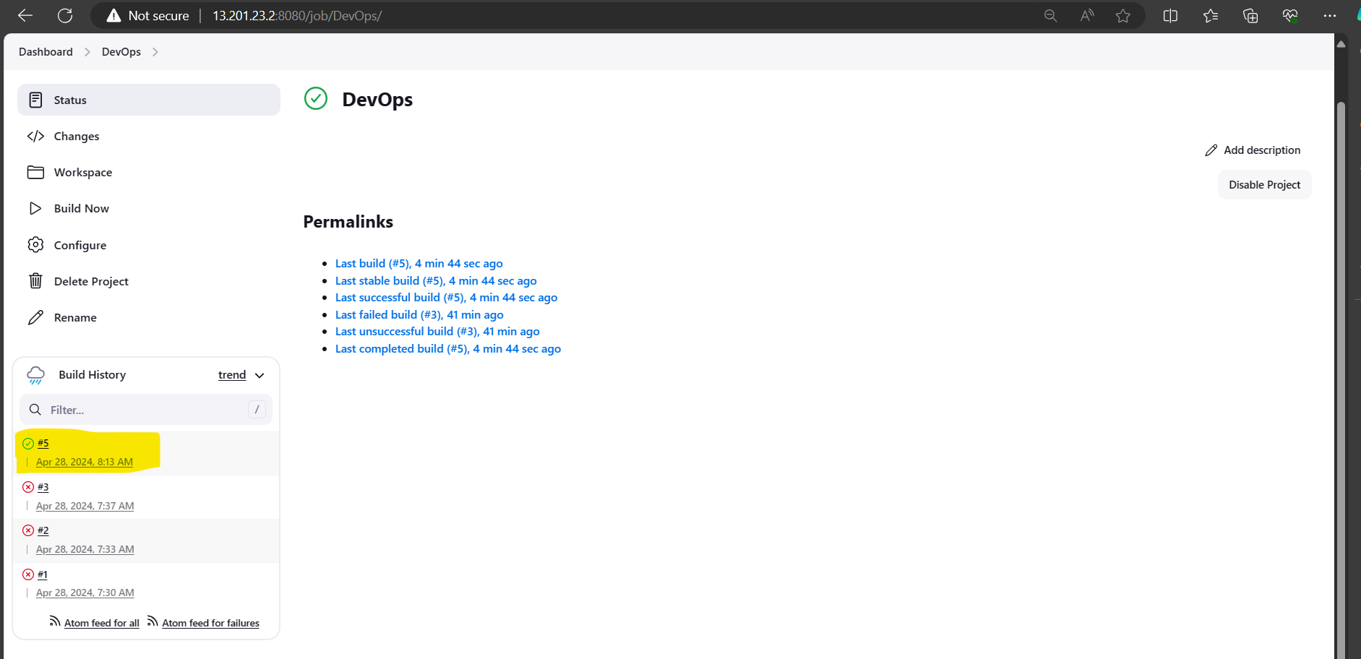

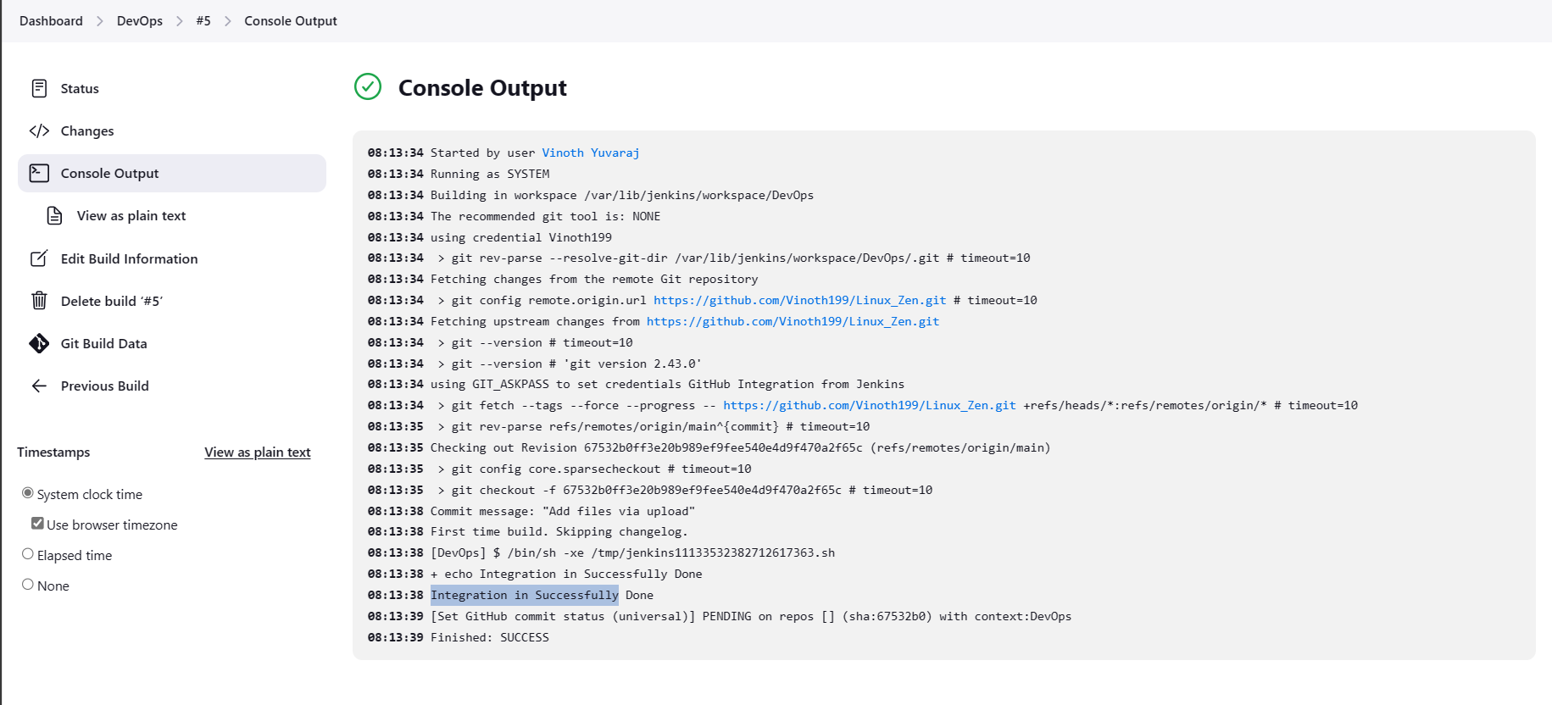

# Create User

